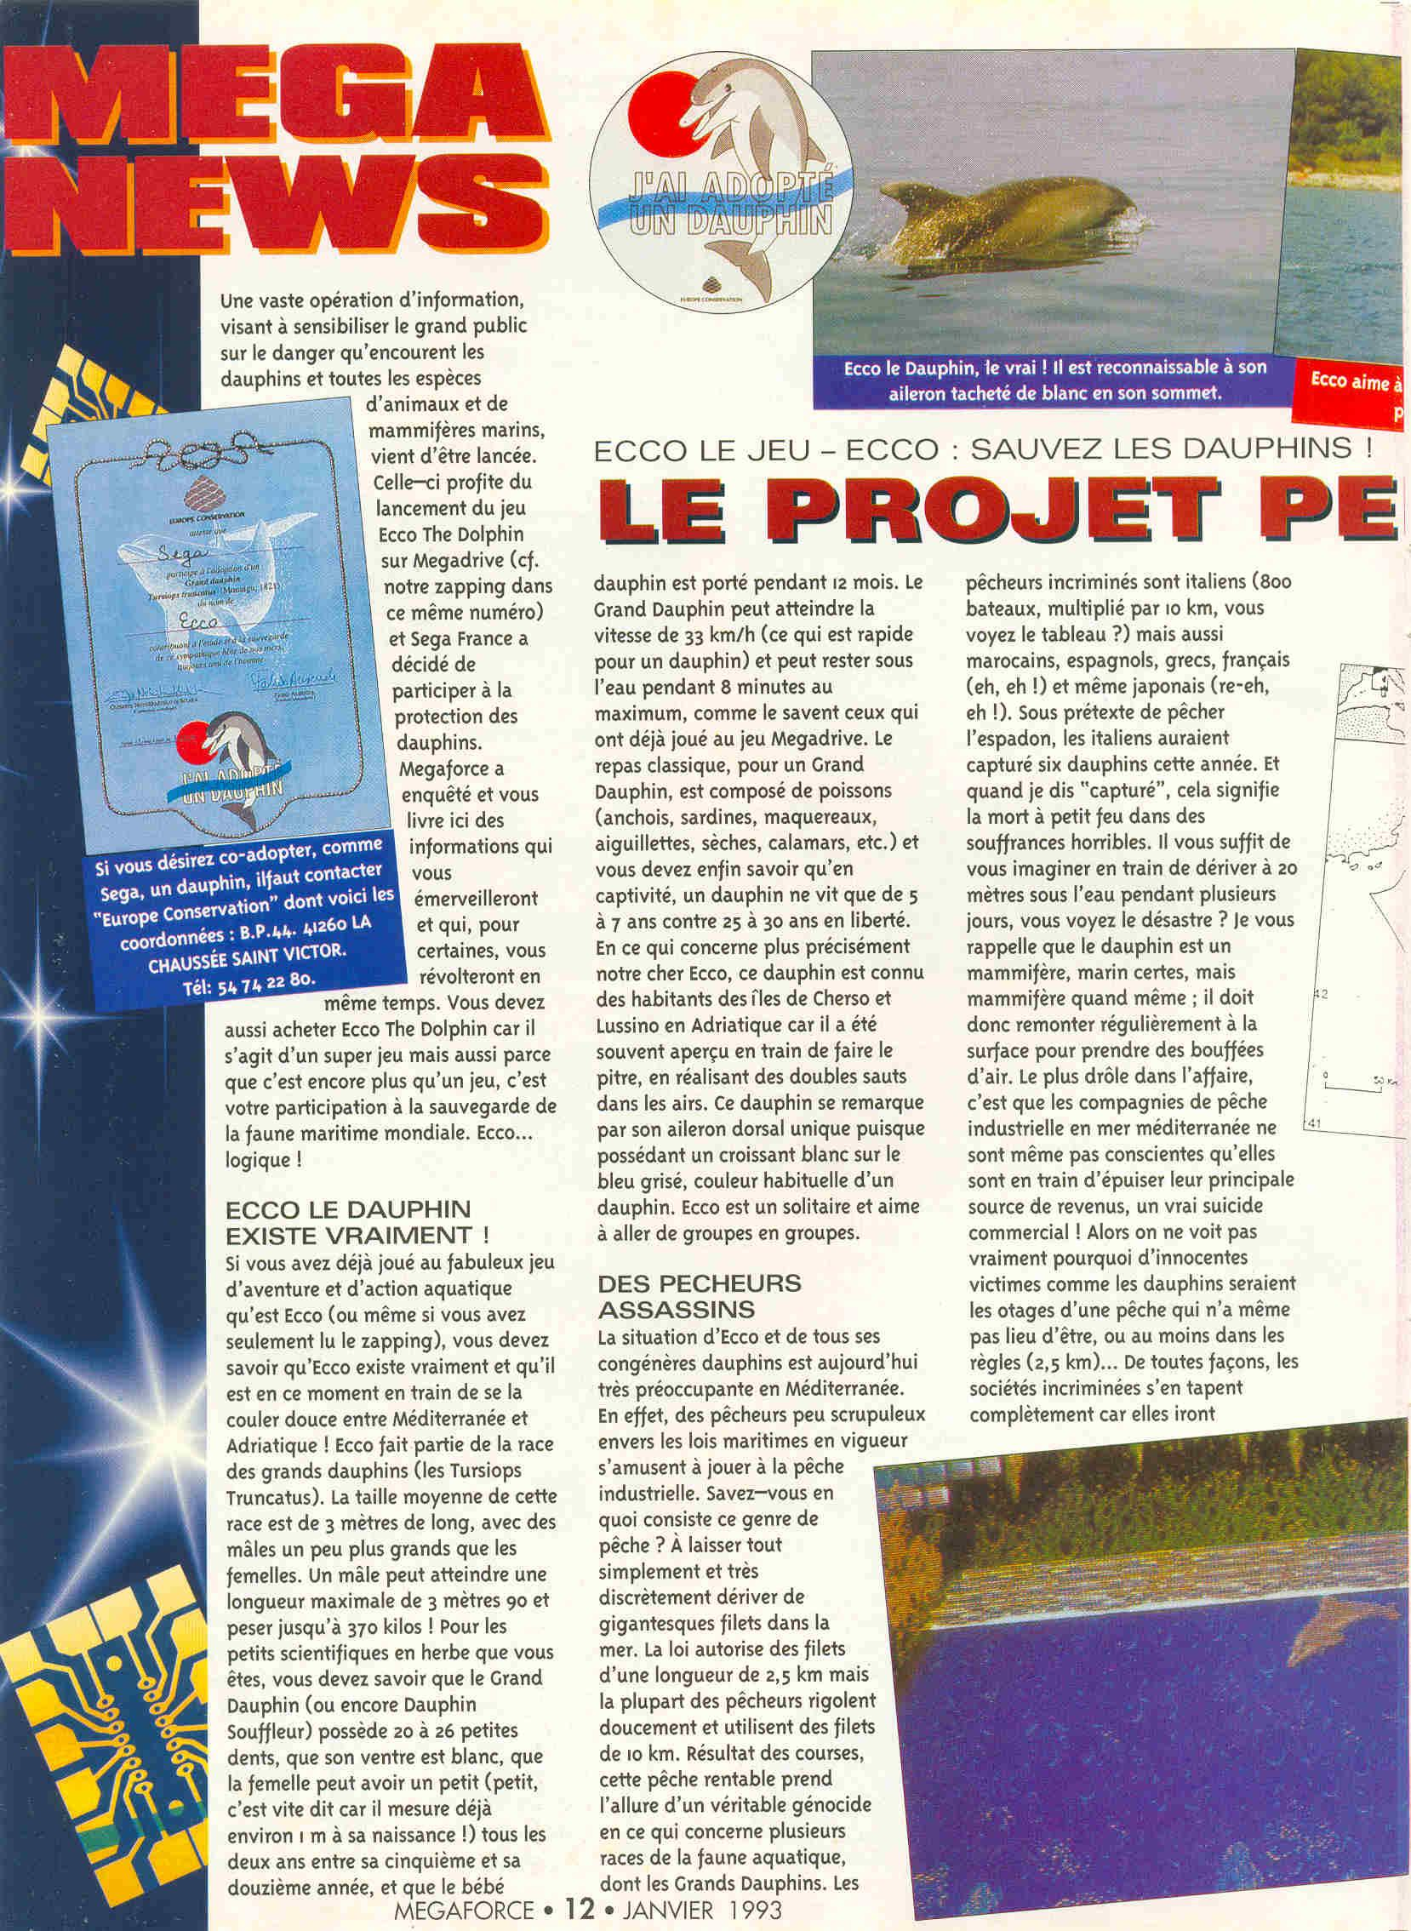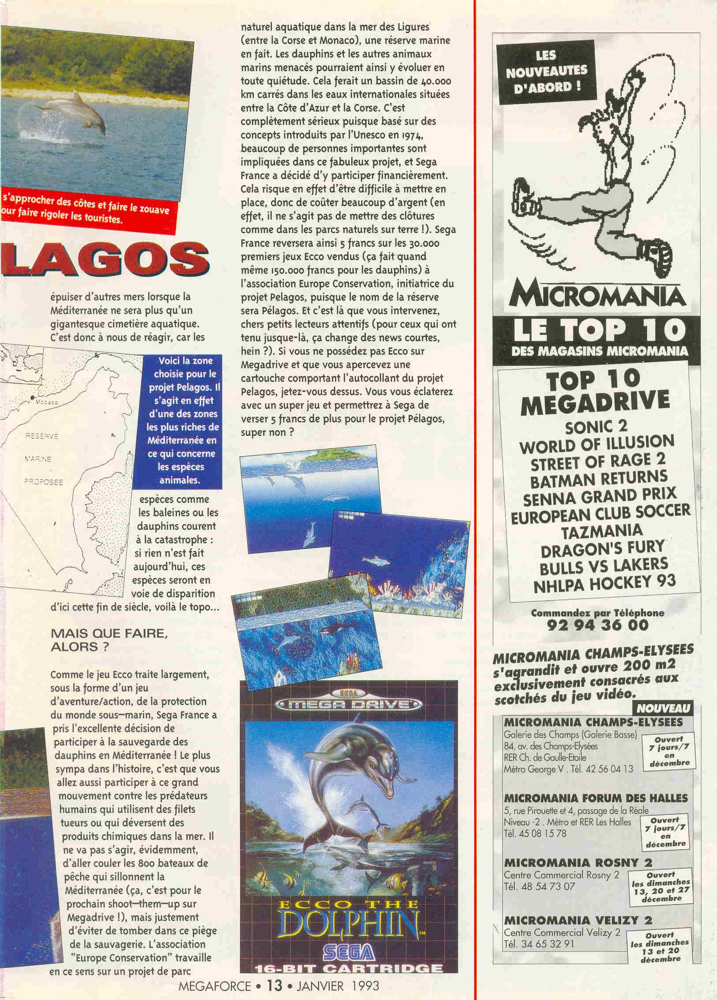

MEGA NEWS
ECCO THE GAME - ECCO: SAVE THE DOLPHINS!
THE PROJECT PELAGOS

Megaforce January 1993, pages 12-13
Translated from French by J. P. “Yuki” Savard for Ecco the Dolphin Online

A vast information operation, aimed at sensitizing the general public on the danger faced by dolphins and all animal species and marine mammals, has just been launched. It’s taking advantage of the launch of the Ecco The Dolphin game on Megadrive (see our zapping in this same issue) and Sega France decided to take part in the protection of dolphins. Megaforce has investigated and gives you here information that will amaze you and, for some, will revolt you at the same time. You also need to buy Ecco The Dolphin since it’s a great game but also it’s even more than a game, it’s your participation in the safeguard of the world maritime fauna. Ecco… logical!

ECCO THE DOLPHIN REALLY EXISTS!

If you’ve already played the fabulous aquatic adventure and action game that is Ecco (or even if you’ve only read the zapping), you should know that Ecco really exists and he’s currently taking it easy between the Mediterranean and Adriatic seas! Ecco is part of the bottlenose dolphin (TN: literally, great dolphin) breed (the Tursiops Truncatus). The average size of this breed is 3 metres in length, with some males somewhat larger than females. A male can reach a maximum length of 3 metres 90 and weigh up to 390 kilos! For the small budding scientists you are, you should know that the Bottlenose Dolphin (or Blower Dolphin) possess 20 to 26 small teeth, that its belly is white, that the female can have one child (child (TN: literally a small one), it’s easy to say since it measures already 1m at birth!) every two year between its fifth and twelfth year, and that the baby dolphin is carried for 12 months. The Bottlenose Dolphin can reach a speed of 33 km/h (which is fast for a dolphin) and can stay underwater for up to 8 minutes, as those who played the Megadrive game would know. The classic meal, for a Bottlenose Dolphin, is composed of fish (anchovies, pilchard, mackerel, cornetfish (TN: ?), squid, etc.) and you should finally know that in captivity, a dolphin only lives 5 to 7 years against 25 to 30 years in liberty. Concerning more precisely our dear Ecco, this dolphin is known by the inhabitants of the islands of Cherso and Lussino in the Adriatic as it has often been seen doing a buffoon of himself, performing double jumps in the air. This dolphin can be noticed by his unique dorsal fin since it has a whice crescent on the gray blue, the usual color of a dolphin. Ecco is a loner and likes to go from groups to groups.

MURDEROUS FISHERMEN

Ecco’s situation and that of all of his dolphin congeners is very worrying today in the Mediterranean. Indeed, fishermen unscrupulous towards the maritime laws in force have fun playing industrial fishing. Do you know what this kind of fishing is? Simply and very discreetly let gigantic nets to drift in the sea. The law allows nets 2.5 km in length but some fishermen laugh softly and use 10 km nets. Result of the races, this profitable fishing takes on the appearance of a veritable genocide with regard to several breeds of the aquatic fauna, including Bottlenose Dolphins. The offending fishermen are Italian (800 boats, multiplied by 10 km, you see the picture?) but also Moroccan, Spanish, Greek, French (eh, eh!) and also Japanese (eh, eh again!). Under the pretense of fishing for swordfish, Italians probably have captured six dolphins this year. And when I say “captured”, this means a slow death in horrible suffering. You just need to imagine yourself drifting 20 metres underwater for a few days, you see the disaster? I remind you the dolphin is a mammal, certainly marine, but still mammal; it must regularly rise to the surface to take some air puffs. The funny thing in the story is that industrial fishing companies in the Mediteranean Sea aren’t even aware they’re exhausting their principal source of income, a real commercial suicide! So we don’t really see why innocent victims like dolphins would be hostages of a fishery that doesn’t even have to be, or at least in the rules (2.5 km)... Anyway, the offending societies completely don’t care because they’re going to exhaust other seas then the Mediteranean will be nothing more than a gigantic aquatic cemetery. It’s therefore up to us to react, because species such as whales or dolphins are heading for disaster: if nothing is done today, these species will be endangered by this end of the century, here’s the story…

BUT WHAT TO DO, THEN?

As the Ecco game deals largely, in the form of an adventure/action game, with the underwater world protection, Sega France took the excellent decision to participate in the saving of the dolphin in the Mediteranean Sea! The coolest thing in the story is that you’re also going to participate in this great movement against human predators who use killer nets or dump chemicals in the sea. It’s not about, obviously, going to sink the 800 fishing boats that ply the Mediteranean (that’s for the next shoot-them-up on Megadrive!) but more to avoid falling into this trap of savagery. The association “Europe Conservation” is working in this direction on a project of aquatic natural park in the Ligurian Sea (between Corsica and Monaco), a marine reserve, in fact. The dolphins and other endangered marine animals could thus evolve there in peace. That would make a 40000 square km basin in the international waters between the French Riviera and Corsica. It’s totally serious since based on concepts introduced by Unesco in 1974, a lot of important people are involved in this fabulous project, and Sega France decided to participate financially. It might be difficult to set up, therefore costing a lot of money (indeed, you can’t put up fences like in the natural parks on earth!). Sega France will thus donate 5 francs for each of the first 30000 Ecco games sold (that’d nevertheless make 150000 francs for the dolphins) to the Europe Conservation association, initiator of the Pelagos project, since the name of the reserve will be Pelagos. And this is where you come in, dear attentive little readers (for those who held up until now, it’s a change from short news, eh?). If you don’t own Ecco on Megadrive and you notice a cartridge with a sticker for the Pelagos project, jump on it. You’ll have fun with a great game and you’ll let Sega give another 5 francs for the Pelagos project, great, eh?

Left:
If you want to co-adopt, you need to contact “Europe Conservation” whose contact details are: C.P. 44. 41260 LA CHAUSSÉE SAINT VICTOR Phone: 54 74 22 80

Top, from left to right:
I ADOPTED A DOLPHIN
Ecco the Dolphin, the real one! He’s recognizable by his white speckled fin at the top.
Ecco likes to approach the coast and be silly to make tourists laugh.

Right center:
PROPOSED MARINE RESERVE
Here is the chosen zone for the project Pelagos. It’s indeed one of the richest areas of the Mediterranean in terms of animal species.

